CALLENDER, Donté M D | TAYLOR, Tevin R

TD Technologies

花 商店

A software requirements Specification document

**Table of Contents**

**Introduction** 1

**Background** 1

**Purpose** 1

**Stakeholders** 1

**Project Constraints** 2

**Requirement Constraints** 2

**Functional Requirements** 3

**Use Cases** 3

# **Introduction**

**Introduction**

### **Background**

The Flower Shop is a sizeable chain of flower stores situated across different parts of Suzhou, China. As of 2016, the Flower Shop conducted a customer satisfaction survey and suggestion box at several of the store locations in order to determine ways to improve their customer pool and overall satisfaction rating. As a result of the survey and suggestion box, the flower chain store concluded that majority of customers preferred a more convenient and efficient method of purchasing flowers. Subsequently, The Flower Shop contracted TD Technologies to develop a mobile application to fulfil the aforementioned requirements.

### **Purpose**

花 商店 or Flower Shop is a mobile app developed for The Flower Shop as a convenient method for its customers to research and purchase flowers. Through the application, the user is able to view a variety of flowers that the store provides and detailed information about the product. After the user has finished viewing the product the user is then able to add the product to their cart to then pay for.

### **Stakeholders**

* + 1. The CEO of The Flower Shop
    2. The CFO of The Flower Shop
    3. The Branch Managers of the Flower Shop
    4. The customers of The Flower Shop.

# **Project Constraints**

**Project Constraints**

### **Requirement Constraints**

* + 1. It should be a mobile application capable of utilizing the internet as users need to make purchases.
    2. It should be localized to the Suzhou area in Jiangsu, China since the stores are located in Suzhou, when purchases are made, the order will be sent to the nearest store.
    3. The application will be designed to suit a smaller screen and as a result will be fairly simple as to avoid appearing congested.
    4. The application was designed with screen latency and proper response time as high priority since having a smooth flowing application would be more pleasing to the users.
    5. Network issues as it relates to network latencies and failure points. Contingencies must me put in place as to avoid losing users due to constant failure.

### **Operating Environment**

* Operating System: Android
* Version: Android 6.0+

# **Functional Requirements**

**Functional Requirements**

1. The user must be able to log in to the application as to provide a level of security in the event of making transactions.
2. The user must be able to view the flowers available in the store by proximity to them.
3. The user must be able search for flowers as to add a level of convenience.
4. The user must be able to make purchases.

### **Use Cases**

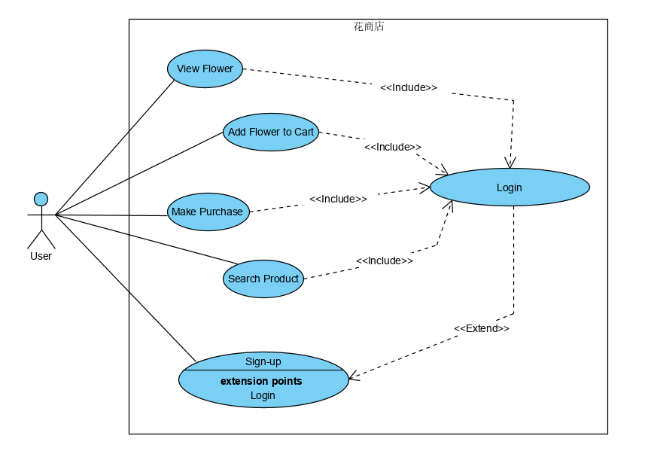

|  |  |
| --- | --- |
| 花商店 | |
| Use Case 1.0 | Sign-up |
| Actor | User |
| Description | A user signs up for the mobile application. |
| Dependencies | N/A |
| Preconditions | * N/A |
| Basic Sequence | 1. The user selects the sign-up button from the login page. 2. The user is prompted to sign up. |
| Post-COnditions | * The user account is created. |

|  |  |
| --- | --- |
| 花商店 | |
| Use Case 2.0 | Login |
| Actor | User |
| Description | A user logs into the mobile application. |
| Dependencies | Sign-up |
| Preconditions | * The user has signed up. |
| Basic Sequence | 1. The user has entered their credentials on the login page. 2. The selects the login button from the login page. |
| Post-COnditions | * The user is logged in. |

|  |  |
| --- | --- |
| 花商店 | |
| Use Case 3.0 | View Flower |
| Actor | User |
| Description | A user views a flower. |
| Dependencies | N/A |
| Preconditions | * The user has logged in. |
| Basic Sequence | 1. The user logs in. 2. The user selects a flower to view. |
| Post-COnditions | * A flower is displayed. |

|  |  |
| --- | --- |
| 花商店 | |
| Use Case 4.0 | Add Flower to Cart |
| Actor | User |
| Description | A user adds a flower to cart. |
| Dependencies | N/A |
| Preconditions | * The user viewed a flower. |
| Basic Sequence | 1. The user views a flower. 2. The selects the add to cart button on the view page. |
| Post-COnditions | * The flower is added to the cart. |

|  |  |
| --- | --- |
| 花商店 | |
| Use Case 5.0 | Make Purchase |
| Actor | User |
| Description | A user makes a purchase. |
| Dependencies | Add flower to cart. |
| Preconditions | * The user added at least one flower to the cart. |
| Basic Sequence | 1. The user goes to the cart after adding a flower. 2. The user selects they pay button. 3. The user is prompted to select a payment method. |
| Post-COnditions | * The purchase is made. |

|  |  |
| --- | --- |
| 花商店 | |
| Use Case 6.0 | Search |
| Actor | User |
| Description | A user searches for a specific flower. |
| Dependencies | N/A |
| Preconditions | * The user has logged in. |
| Basic Sequence | 1. The user selects the search option on the navigation bar. 2. The user is redirected to a search page. |
| Post-COnditions | * The desired flower is displayed. |